Geography Pre-Test
Identify the choice that best completes the statement or answers the question.

 | 1. | Monsoons are most commonly found in ----  a. northeastern Europe c. southern Asia  b. western Africa d. southwestern Australia
 | 2. | 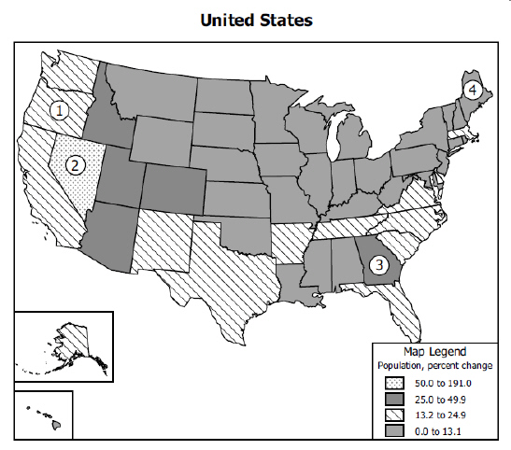  According to this map, which numbered state has the highest population growth rate?  a. 1 c. 3  b. 2 d. 4
 | 3. | Which city is located closest to the prime meridian?  a. Montreal, Canada c. Moscow, Russia  b. London, England d. Stockholm, Sweden

4. |  | Which source would provide the most accurate information about a group’s culture?  a. Satellite images c. World globe  b. Field work d. Elevation maps
 | 5. | Which natural hazard is most likely to cause crop failures in the Great Plains region of the United States?  a. Drought c. Seasonal flooding  b. Earthquake d. Volcanic eruption
 | 6. | Which factor is least important in selecting the location for a factory?  a. Access to schools c. Zoning laws  b. Distribution of populations d. Transportation networks

 | 7. | Which term do geographers use to classify an area with unifying physical characteristics?  a. Location c. Region  b. Orientation d. Perception
 | 8. | 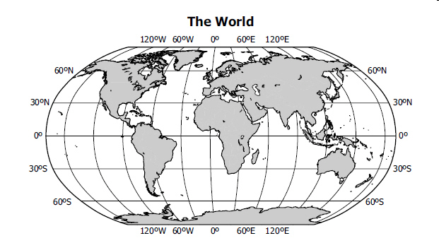  30°N, 120°E is located within the continent of ---  a. Asia c. Australia  b. Europe d. North America
 | 9. | 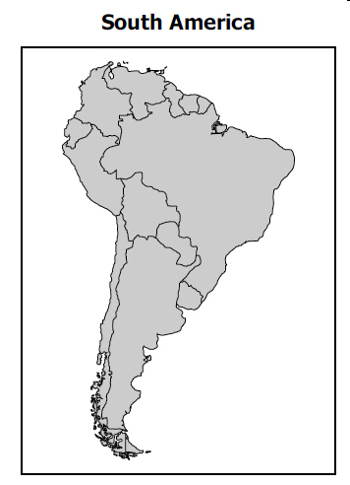  Which South American country does NOT border the Pacific Ocean?  a. Peru c. Ecuador  b. Chile d. Brazil
 | 10. | Distortion is a problem when mapping Earth because--  a. Earth’s curved surface is transferred to a flat surface  b. current map-producing technology is limited  c. Earth’s populations are constantly changing  d. climate conditions are difficult to measure
 | 11. | 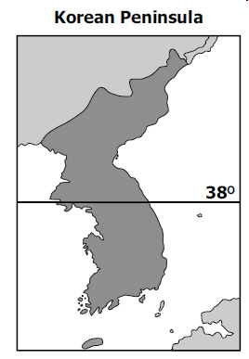  This peninsula has been divided as the result of ________.  a. religious differences c. a language barrier  b. a political dispute d. physical characteristics
 | 12. | In the 1990s, ethnic diversity as a divisive force best described conditions in which country?  a. Brazil c. Switzerland  b. Japan d. Yugoslavia
 | 13. | 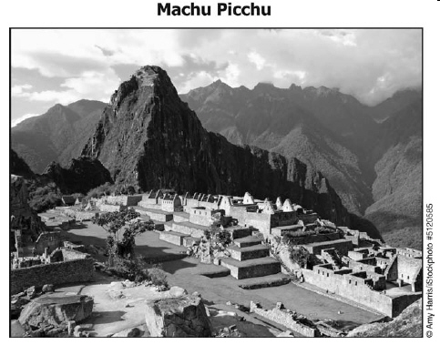  The site shown in this photograph is part of the cultural landscape of --  a. Southeast Asia c. Eastern Europe  b. North Africa d. Latin America
 | 14. | Which religious group is associated with worshiping in mosques?  a. Christians c. Buddhists  b. Muslims d. Hindus
 | 15. | Which factor explains why a number of animal species are unique to Australia?  a. Diverse vegetation c. Humid climate  b. Rough terrain d. Geographic isolation
 | 16. | Industrialization and economic development affect human settlement patterns by --  a. prohibiting people from inhabiting harsh climate regions  b. enabling people to live farther from natural resources  c. permitting mass migration to rural areas  d. causing the rapid decline of urban populations
 | 17. | 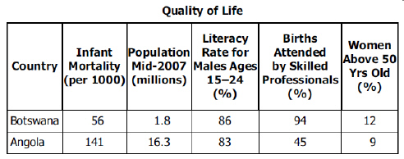  Based on this data, what is one reason the infant mortality rate is higher in Angola then in Botswana?  a. The population is greater in Botswana.  b. The literacy rate in Angola for males 15 to 24 is higher.  c. Fewer births are attended by skilled professionals in Angola.  d. Many of the women in Botswana are 50 and older.
 | 18. | 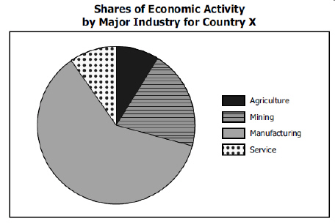  Which list correctly ranks this country’s levels of economic activity from largest to smallest?  a. Primary, Secondary, Tertiary c. Secondary, Primary, Tertiary  b. Secondary, Tertiary, Primary d. Tertiary, Primary, Secondary
 | 19. | 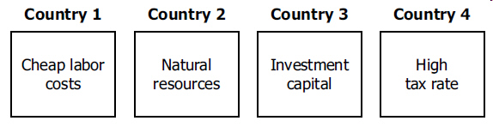  In which country would a clothing company most likely locate its jeans factory?  a. 1 c. 3  b. 2 d. 4

20. What are the five themes of geography?
a. social, cultural, political, economic, and physical
b. political, human-environment interaction, region, place, and culture
c. human-environment interaction, place, region, movement, and location
d. region, movement, location, cultural, and economic

